Problem Specification and the usecase document.

|  |  |  |  |  |  |  |
| --- | --- | --- | --- | --- | --- | --- |
| S.no | Date | Modified Module | Purpose of Modification | Modified by | Reviewed By | Review Comments |
| 1 | 14/3/2020 |  |  | Udai |  |  |
|  |  |  |  |  |  |  |
|  |  |  |  |  |  |  |

1.**Introduction** : Water distribution to the people and industry is a national necessity. The goals are usually set by the government for distributing drinking water to a locality based on the population and the percapita income.

2.Domain Description:Given below are the various components of water management that affect the goal.

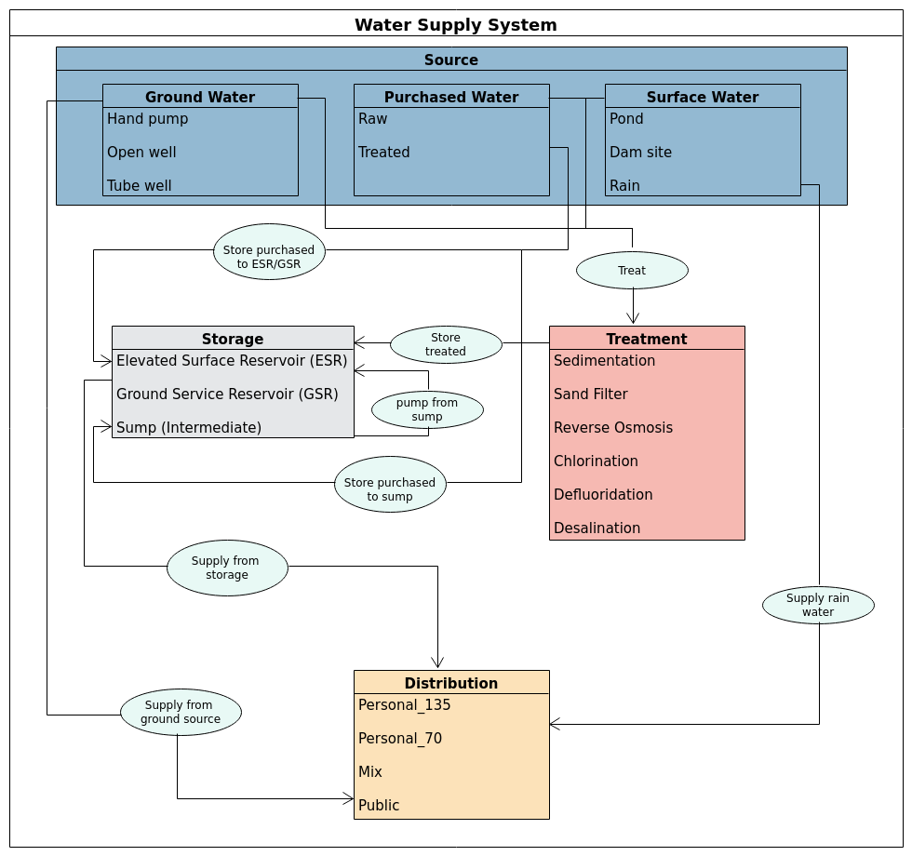

To be completed by Udai:

Water Distribution:

Ground water (Water fed by Aquifers):

Purchased Water (Water brought into the geographical boundry from elsewhere):

Surface Water

Storage

Treatment:

Issues in dealing with Rain Water:

Issues in modeling water present in a container:

3.Problem Description

3.1 The Goals to be achieved – Quantitative measures and units to be explained like the litres per average percapita of the locality

3.2 The subgoals to be achieved

3.3 Diagnostic goals to be achieved

3.4 The potential processed involved in realtime management. (Not too detailed since this will be part of the detailed specification)

Usecases: To be completed by Udai

A: The use case of water flowing from a tank connected to another tank

B:The use case of water flowing from a tank to another tank through a pump

C: The use case of water levels being unfavourable for transport between two tanks

D: Use case of Pipe being clogged

Udai can add more.